MySQL Rename Table

Sometimes our table name is non-meaningful, so it is required to rename or change the name of the table. MySQL provides a useful syntax that can rename one or more tables in the current database.

Syntax
mysql> RENAME old_table TO new_table;

RENAME TABLE old_tab1 TO new_tab1,
old_tab2 TO new_tab2, old_tab3 TO new_tab3;

MySQL RENAME TABLE Example :

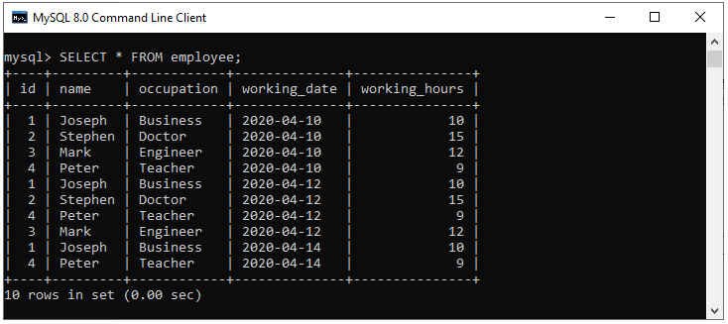

mysql> RENAME employee TO customer;

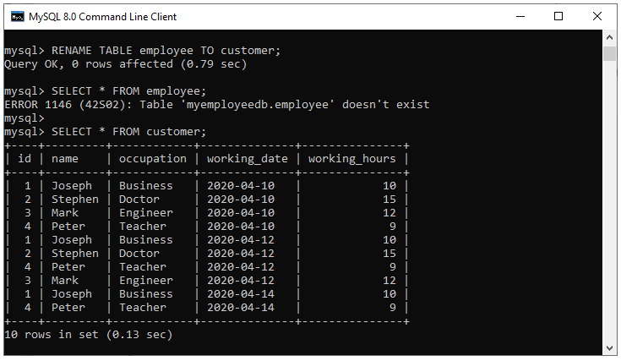

RENAME Multiple Tables :

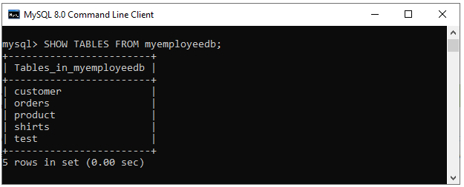

mysql> RENAME TABLE customer TO employee, shirts TO garments;

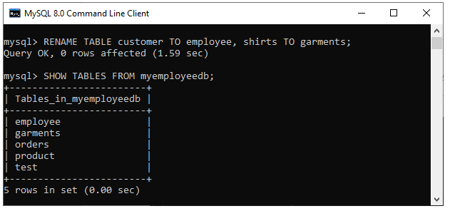

Rename table using ALTER statement :

Syntax :
ALTER TABLE old_table_name RENAME TO new_table_name;

Example :
mysql> ALTER TABLE garments RENAME TO shirts:

